**Homework 2: Route Finding**

**Report Template**

**Please keep the title of each section and delete examples. Note that please keep the questions listed in Part III.**

**Part I. Implementation (6%):**

* **Please screenshot your code snippets of Part 1 ~ Part 4, and explain your implementation. For example,**

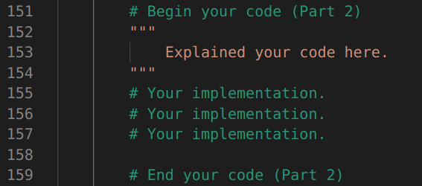

**Part II. Results & Analysis (12%):**

* **Please screenshot the results. For instance,**

Test1: from National Yang Ming Chiao Tung University (ID: 2270143902)

to Big City Shopping Mall (ID: 1079387396)

BFS:

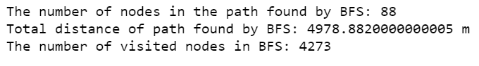

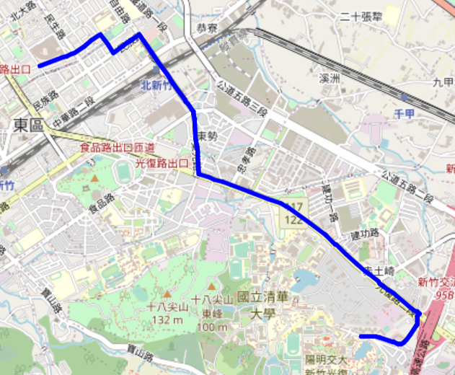

DFS (stack):

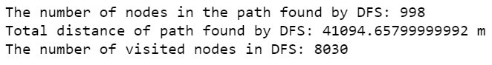

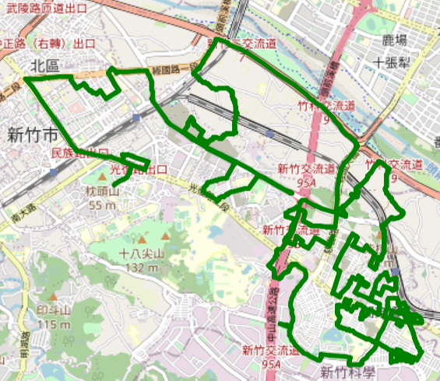

**Part III. Question Answering (12%):**

1. Please describe a problem you encountered and how you solved it.
2. Besides speed limit and distance, could you please come up with another attribute that is essential for route findingin the real world? Please explain the rationale.
3. As mentioned in the introduction, a navigation system involves mapping, localization, and route finding. Please suggest possible solutions for **mapping** and **localization** components?
4. The estimated time of arrival (ETA) is one of the features of Uber Eats. To provide accurate estimates for users, Uber Eats needs to dynamically update ETA based on their mechanism. Please define a **dynamic heuristic** **equation** for ETA and explain the rationale of your design. Hint: You can consider meal prep time, delivery priority, multiple orders, etc.